SESSION 12 ASSIGNMENT 3

**Problem**: Create a list of tuples, where the 1st element of the tuple is an int and the second

element is a string.

Example - ((1, ‘alpha’), (2, ‘beta’), (3, ‘gamma’), (4, ‘zeta’), (5, ‘omega’))

- for the above list, print the numbers where the corresponding string length is 4

- find the average of all numbers, where the corresponding string contains alphabet ‘m’

or alphabet ‘z’

**Code**:

package com.aman

import scala.collection.mutable.ListBuffer

class session_12_3 {

var tuple_new = ((1,"alpha"),(2,"beta"),(3,"gamma"),(4,"zeta"),(5,"omega"))

*//Displaying the number corresponding to length of 4 by using tuple iterator*

def first():Unit={

println("Numbers corresponding to string with length 4 :")

tuple_new.productIterator.foreach{ case (s,i) => if(i.toString.length == 4) println(s) }

}

*//tuple iterator used to find string which has “m” or “z” characters and then finding length of them*

*//summing them and finding the average*

def second():Unit={

println("Average of all numbers, where the corresponding string contains alphabet ‘m’ or alphabet ‘z’ :")

var temp = List[Int]()

tuple_new.productIterator.foreach{ case (s,i) => (if(i.toString.indexOf("m") != -1 || i.toString.indexOf("z") != -1) temp ::= s.toString.toInt) }

println(temp.sum/temp.length)

}

}

object exec extends App{

var define = new session_12_3;

println("\nWe will be working on following tuple " + define.tuple_new.toString())

var first = define.first()

var second = define.second()

}

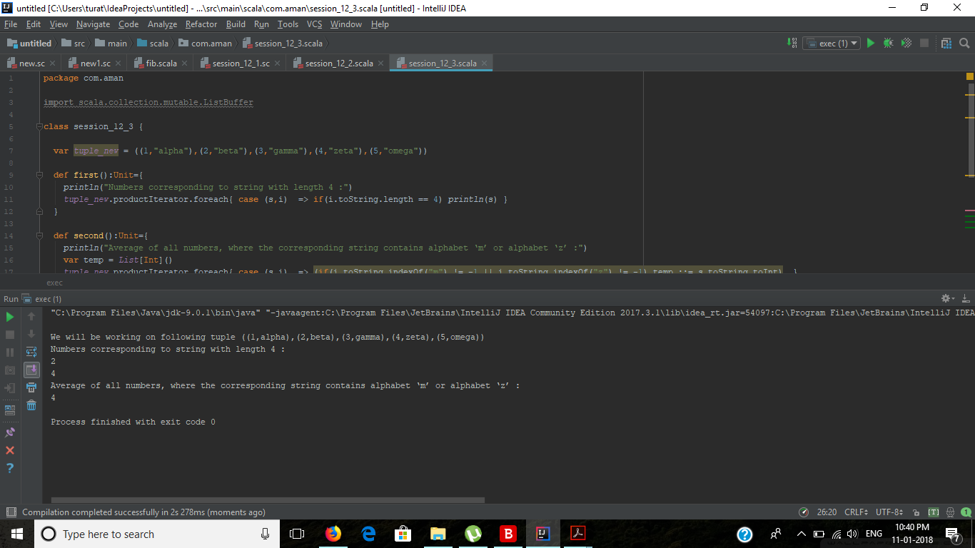

**Output**:

We will be working on following tuple ((1,alpha),(2,beta),(3,gamma),(4,zeta),(5,omega))

Numbers corresponding to string with length 4 :

2

4

Average of all numbers, where the corresponding string contains alphabet ‘m’ or alphabet ‘z’ :

4

Process finished with exit code 0